NATIONAL SKI PATROL Date
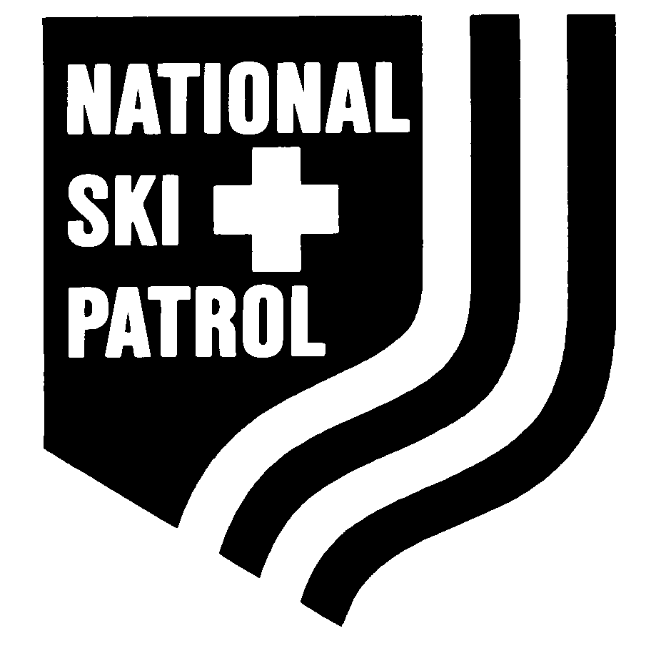
133 South Van Gordon, Suite 100
Lakewood, CO 80228-1706

Please refer to Chapter 10 of the current version of NSP Policies and Procedures
for award guidelines before completing this form.

ALL SUBMISSIONS

1. Nominee’s Name | ABSOLUTELY NO NICKNAMES- IF THE NAME IS DAVID DO NOT WRITE DAVE | NSP ID

SIGNATURES FOR ALL

APPOINTMENTS DSA MERIT STARS CERTIFICATES OF APPRECIATION

45 DAYS ARE REQUIRED BY THE NATIONAL OFFICE FOR PROCESSING AND MAILING OF AWARDS FROM DATE RECEIVED IN THE NATIONAL OFFICE

THIS MEANS FROM THE TIME I SEND IT TO BILL AND HE SENDS IT TO NATIONAL!!!!!!!

APPROVALS Print Sign
Sponsor | HE OR SHE PRINTS HERE AND SIGNS HERE | Date Signed | DATE
NSP Patrol Representative | HE OR SHE PRINTS HERE AND SIGNS HERE | Date Signed | DATE
Section Chief/Region Director | YOUR RD MUST sign here (if you wish the SC can also) | Date Signed | DATE
Review Board Chair | REGION AWARDS ADVISOR PRINTS HERE AND SIGNS HERE | Date Signed | DATE
Division Awards Advisor | LEAVE THIS ALONE | Date Signed
Division Director/Designee | LEAVE THIS ALONE | Date Signed
National Awards Coordinator | LEAVE THIS ALONE | Date Signed

OUTSTANDING PATROLS AND PATROLLERS

APPROVALS Print Sign
NSP Patrol Representative | HE OR SHE PRINTS HERE AND SIGNS HERE | Date Signed | DATE
Section Chief/Region Awards Advisor | YOUR SECTION CHIEF AND/OR RD PRINTS HERE AND SIGNS HERE | Date Signed | DATE
Region Director | YOUR REGION DIRECTOR PRINTS HERE AND SIGNS HERE | Date Signed | DATE
Review Board Chair | REGION AWARDS ADVISOR PRINTS HERE AND SIGNS HERE | Date Signed | DATE
Division Awards Advisor | LEAVE THIS ALONE | Date Signed
Division Director/Designee | LEAVE THIS ALONE | Date Signed
National Awards Coordinator | LEAVE THIS ALONE | Date Signed

NOMINATION

MERITORIOUS SERVICE AWARD

APPROVALS Print Sign
Region Director | RD IF SUBMITTING (DOES NOT NEED TO GO THROUGH COMMITTEE) | Date Signed | DATE
Division Director | LEAVE THIS ALONE | Date Signed
Division Awards Advisor | LEAVE THIS ALONE | Date Signed

5. Award to read:
For meritorious service as the TITLE for the TITLE Region/Division from DATE to DATE

SUBMISSION
PATROLLER'S CROSS

These do not need to go through committee

APPROVALS Print Sign
Sponsor | HE OR SHE PRINTS HERE HE OR SHE SIGNS HERE | Date Signed | DATE
NSP Patrol Representative | HE OR SHE PRINTS HERE HE OR SHE SIGNS HERE | Date Signed | DATE
Region Awards Advisor | REGION AWARDS ADVISOR PRINTS HERE AND SIGNS HERE | Date Signed | DATE
Division Awards Advisor | LEAVE THIS ALONE | Date Signed
Division Director/Designee | LEAVE THIS ALONE | Date Signed

WORDING ON CERTIFICATES MERIT STARS AND DSAs
(LIMITED SPACE)

THERE IS LIMITED SPACE- THE WORDING DIRECTLY BELOW WHICH I RECEIVED VIOLATES HIPPA
“saving the life of the mother of his fraternity brother at the Phi Kappa Tau Fraternity House at Michigan Technological University in Hancock Michigan on February 8, 2008”

THIS ONE IS WAY TOO LONG
“The National Ski Patrol hereby awards the NSP Distinguished Service Award to John Smith for his exceptional service to his patrol, his region, his division, and the National Ski Patrol

LIMIT THE SPACE!!!!!!!!!!!!!!!!!!!!!!!!!!!!!!!!!!!!!!!

To whom award should be sent: (To be completed by Division)

Name | REGION AWARDS ADVISOR ONLY PRINTS HIS OR HER NAME AND ADDRESS ON ALL SUBMISSIONS WITH THE EXCEPTION OF OUTSTANDINGS PATROLS AND PATROLLERS I DO THIS
Address
City, State, Zip
Date Needed | CONSIDER YOUR BANQUET AND THEN THE 45 DAY RULE- IF YOU SEND THEM TO ME TOO LATE, YOU WILL NOT GET THE AWARDS IN TIME FOR YOUR BANQUET. ALSO DO NOT SEND ME DATES THAT ARE IMPOSSIBLE. LET ME KNOW WHEN YOUR BANQUET IS. I RECEIVED A SUBMISSION IN OCTOBER FOR A SEPTEMBER “DATE NEEDED”  NATIONAL ALSO NEEDS TO KNOW WHEN THE NOMINEES CAN BE PUBLICALLY POSTED- IF YOU DO NOT GIVE OUT AN APPOINTMENT AT YOUR BANQUET, AND DO NOT LET ME KNOW WHEN I SEND THE SUBMISSION IN TO NATIONAL, IT WILL BE POSTED ON THE NATIONAL SITE ON THE DATE WHEN YOU REQUEST IT. THIS MEANS YOU MAY HAVE A PERSON RECEIVING AN APPOINTMENT WHO FINDS OUT ABOUT IT BEFORE HE HAS RECEIVED IT

