Directions for Use of this Worksheet

The purpose of this worksheet is to assist in gathering the information needed to complete the Outstanding Patroller Award form. The worksheet is designed to assist with sections 1 through 14 of the form and additional documentation needed. The more you can identify on the worksheet, the more likely the nomination will be approved by Region, Division, and National Award Committees.

There are twelve categories for Outstanding Patrollers (thirteen counting the Central Division Outstanding Nordic Patrol Representative): Alpine Patroller, Administrative Patroller, Alumni (NEW), Bike (NEW), Nordic Patroller, Patrol Director/Representative, Patroller (formerly Auxiliary), Young Adult Patroller (age 15-19), Patrol Director/Representative – Paid (NEW), Patroller – Paid, Instructor – OEC and Instructor – Non-OEC.

Always use the current year’s forms. Font size on the forms is 9 point Times New Roman. Do not use smaller font size. If you do, when the font is changed back to 9 point, this could affect the number of pages on your award and may result in the nomination being disqualified. This means the Outstanding Patroller submissions cannot exceed the signed cover sheet and 4 additional pages. The letter of recommendation is no longer required. In place is Section 14 where this same information should be placed. It should be brief but complete. It should cross reference supplemental data to the numbered sections on the nomination form. Superfluous and repeated information from the form only takes up space and annoys the reviewers.

In order to ensure fairness in the selection process, with the exception of Sections 1-5, none of the sections of the form should include specific names of people, places, regions, patrols, etc. For example, instead of using “Western Region,” write “Region.” Instead of writing “Central Division,” write “Division.” For Section 14, do not use “they” when referring to the patroller’s accomplishments. While not specially prohibited it is best to not use “he/she” or “his/her”, the nomination is more readable using “he” and “she” and is considered appropriate.

The key to success with these nominations is outstanding service in individual events and for extended service to the National Ski Patrol within a time period that includes the current season as well as three previous seasons. For example, this means you can use the 2020-2021 season (if this is the current season), 2019-2020 season, 2018-2019 season, and finally, 2017-2018 season. Any mention of involvement prior to these seasons must be removed from the submission. The only exception is in Section 6; refer to section 6 in the Guidelines for details.

A National Appointment or Leadership Commendation Appointment is not a requirement to receive an Outstanding award. No individual may be nominated for more than one outstanding award in any year. A winner of a National Outstanding award, either an individual or a patrol, cannot reapply for any outstanding award for the following four seasons.

If a nominee has service as a dual registered volunteer and paid patroller and is nominated for any outstanding award other than Outstanding Paid Patroller, the nomination must be considered on the merits of the volunteer service and experience alone. For Outstanding Paid Patroller, the patroller must be registered as paid and all hours and NSP related efforts used in the submission must be done in that capacity as a paid patroller.

Young Adult Patrollers must be registered as Alpine Patroller, Nordic Patroller, or Patroller (or Senior if applicable in these membership categories). Young Adult Patrollers must be less than 20 years of age on June 1 of the year nominated. Candidates are not eligible for Outstanding Awards.

For Outstanding Patroller, Outstanding Alpine, or Outstanding Nordic patrollers, the nominee cannot hold positions or advisorships above patrol level. If they do, they are ineligible for these awards. Outstanding Instructor, Outstanding OEC Instructor, Outstanding Administrative and Outstanding Patrol Representative can hold positions above patrol level. Outstanding Paid PR/PD and Paid Patroller follow the volunteer guide, PR/PD can and the Patroller cannot hold positions above Patrol.

Check member pages to ensure the nominee is current on dues and refreshers. This is especially important if the nominee has taken refreshers at another patrol and this information did not get to the National office.

Make sure the proper individuals sign and print their names on the forms. Either the Awards Advisor or Region Director can sign as review board chair, but National strongly prefers the Region Awards Advisor be the Chair.

For purposes of the award, the current list of Credentialed Programs is as follows:

CPR (AHA, Red Cross or NSC)
Avalanche
Mountain Travel and Rescue
Nordic
Outdoor Emergency Care
Instructor
Instructor Mentoring
Awards
Patrol Board of Directors
Instructor Development
PSIA
AASI

Skiing and Snowboarding Proficiency
CSIM
Newsletter
Introduction to Patrolling
Transportation
Accredited Senior Evaluator (ASE)

These are examples of programs that are NOT credentialed: (These are under area management and not NSP programs’

Chair Evacuation
Snowmobile

The intent of the credentialed program selections is to stimulate thought of what should be included. If a member is part of the resort team that develops and teaches these skills to members it is an important service to the local patrol and resort. A key factor in this and all awards is “what did the nominee do”, not that they held the position. A person might have been a Patrol Board Rep and attended meetings for 20 years and not have done anything else. The question is what did the nominee do as a board member that benefited the patrol and NSP. Did they encourage and help members attain additional training and certification (i.e., Senior, Certified or Nordic Master)? Did they mentor new members to become active in patrol education programs or management?

Please note that as you type in any table, if you pass the end of the space it will expand automatically.
Note: “Thru Date” must be an actual year, NOT “present.”

National Outstanding Patroller of the Year Category
The nomination begins with the selection of the nomination category. Each category is stand-alone; only check one category.

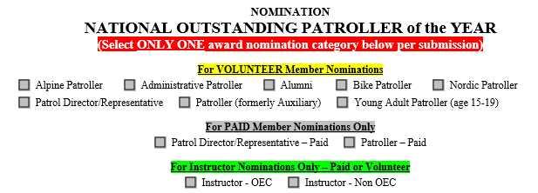

Sections 1-4 – Nominees Information
Section 1-2
The nominees contact information and Patrol registration should be filled out accurately. Use the Patrollers name as it is registered in the National database. Do not use nicknames.

Section 3
Date of Birth is only applicable for Young Adult nominations. The nominee must be less than 20 years of age at the time of submission to the National Awards Advisor.

Section 4
The name of the Patrol the nominee is currently registered with. If the nominee is registered on a secondary Patrol, list Primary Patrol and then the secondary Patrol. List the Division the nominee is registered in.

Sections 5 – Sending, Presentation, Posting, and Signatures
The Send the awards to, presentation, posting dates are to be completed by the Division Awards Advisor or Division Director when the nomination advances to Division level. These dates are usually the dates the award will be presented. After which the award will be entered on the Patrollers profile in the National database.

Date Needed
Should be a date at least a week before the anticipate presentation date. Normal processing varies by Region but always includes review and approval by a Region Committee and review and approval by a Division Committee. After approval by the Division, the award is sent to the National Awards Advisor checked and forwarded to the National Office. Normal processing once the award reaches the National Office can take 45 days. Review at the Division level can take a couple weeks and Region review could ta couple more. Therefore, Applications submitted to the Region at least 10 weeks before the planned presentation date. NOTE: Nominations for this award can only be submitted to the National Awards Advisor in the Spring, usually prior to May 1st of the calendar year.

Public Posting Date
This is usually the date the award will be presented. After which the award will be entered on the Patrollers profile in the National database.

Approvals and Signatures
The appropriate Approval names and Signatures list the correct hierarchy. The only exception is when nominee holds one of these positions. In this case print Nominee in the appropriate field.

Section 6 – Ski Patrol Service
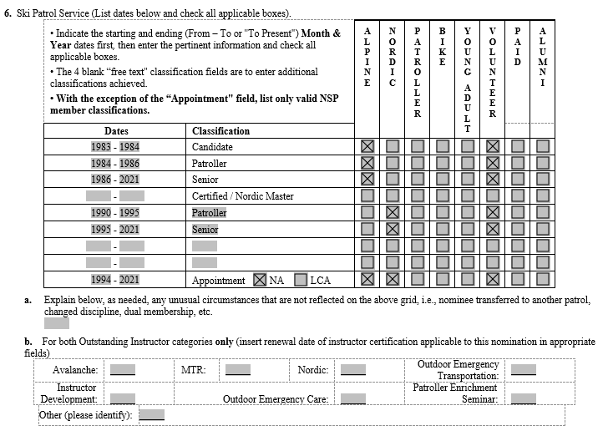

This is the only section where the 4-year rule does not apply. Use part a to describe and define the specifics of breaks in service to the NSP.

Please take note that this example states the patroller is recorded as both an Alpine and Nordic for a few years of service. Also note the different years of which the patroller attained different levels of Senior classification. The Alpine and Nordic columns are for those discipline categories. The Patroller column is what was formerly the Auxiliary category, it is only used when the nominee is unable to or has decided to not transport patients.

Part b is used to describe any breaks or unusual circumstances: such as a break in NSP service because of military, schooling or just being away because of career requirements.

Part b is for use ONLY for Outstanding Instructor - OEC and Outstanding Instructor - Non-OEC. Fill in all the dates and all instructorships (including CPR and PSIA) the nominee has ever had. It shows the reviewers a strong career and adds to their overall feel about the nominee.

Section 7 – NSP Service Time

Use last season’s actual on and off hill duty hours and days open for the area. Use an estimate for this season based on projected hours the nominee is expected to serve. If the nomination is passed on to Division and the current years estimates are found to be lower then actual, these numbers can be adjusted before the nomination is sent out to the Division judges. The corrected numbers must be passed up through the Region Awards Advisor and Division Awards Advisor.

Section 8 – Ski Patrol training courses successfully completed and/or instructed.
Start Date (Year) | Thru Date (Year) | Describe the ski patrol-related courses taught, including dates of classes (most recent listed first), number of students—local, region, or division level.  (for Patrol Rep/Director nominations, how are patrollers performing on the parol.
 |  | - Instructed
 |  | - Instructor and IT hours
 |  | - Completed

Sections 8a and 8b have restrictions on allowable content.
For Outstanding Instructor OEC only OEC classes and CPR classes are allowable entries. Outstanding Instructor Non-OEC the opposite is true, OEC classes are prohibited.

Here are some examples of successful entries for the patrol-related courses completed and/or taught:
a. Instructed
20xx - 20xx: Basic OEC candidate class instructor at nearly every class. Patrol classes have included 10-15 candidates each year
20xx - 20xx: American Heart Association CPR BLS for Healthcare Providers (8 classes each year with 10-15 participants)
2007 - 20xx: Annual Patrol OEC Refresher (100+ patrollers attending each year)

b. Instructor and IT hours
This section can indicate the hours involved in teaching and IT in the review period. An instructor teaching a section or two of a class may put in fewer hours while an IOR will put in much more. Hours QAing refreshers, classes, mentoring new instructors. Specify hours and discipline for each involved.

c. Completed
20xx - 20xx: Annual Patrol OEC Refresher and On the Hill Refresher
20xx - 20xx: Annual Chair Evacuation Refresher
20xx - 20xx: Annual CPR certification
20xx: Region Senior Alpine Skiing
20xx - 20xx: Division Women’s Clinic
20xx: Division OEC Instructor/ IT Conference
20xx: Region Toboggan Enhancement Seminar
20xx: Division Ski Trainer’s Workshop
20xx: Region Senior Alpine Toboggan

Section 9 – NSP leadership positions held:
For Patrol Rep/Director nominations only, indicate how many are patrollers as 9a, 9b, 9c on the patrol

Start Date (Year) |  | Thru Date (Year) |  | List patrol leadership positions and any past leadership positions at or above patrol level that may be applicable within the 4-year time window. List offices, advisorships, committee chairmanships, etc. Show dates starting with most recent

Significant leadership impact on the patrol by any of the above categories:

Here are samples of successful entries for the NSP Leadership question:
20xx - 20xx: Local Patrol Assistant Patrol Director
20xx - 20xx: Local Patrol Awards Committee Chair
20xx - 20xx: Instructor of Record for OEC Candidate class
20xx - 20xx: Patrol Shift Leader
20xx - 20xx: Region Board Recording Secretary

Section 10 – NSP Awards Received
Year | List NSP Awards showing dates starting with the most recent.

Here are samples of successful entries for the Awards question:
20xx: Division Director’s Program Award for Instructor Development Program Development
20xx: Division Director’s Program Award for Nordic Program Development
20xx: Region Outstanding OEC Instructor
20xx: Region Outstanding Service Award
20xx: Local Patrol Bravo Award

Section 11 – Support of NSP
Year | List the NSP programs the nominee was involved in showing dates starting with the most recent; specific ones being the following:  - Promotion of ski safety, accident prevention, and public relations  - Involvement in instruction and evaluation.  - Development of new equipment or procedures.  - Participation in section, region, division, and national committees or programs

Here are samples of successful entries for the support of NSP question:
20xx - 20xx: Coordinates and delivers a minimum of 4-5 Region Instructor Development courses per year 20xx - 20xx: Mentors Instructor Development candidates throughout the Region 20xx - 20xx: Provides Quality Assurance oversight for multiple annual patrol refreshers, OEC instructor annual refreshers and OEC basic candidate evaluations within the region 20xx - 20xx: Serves as a trainer and evaluator for the Region Senior Emergency Management (SEM) training and evaluations 20xx - 20xx: Coordinator of Regional Nordic ski examinations for candidates 20xx - 20xx: Attends Regional and Divisional Nordic ski clinics 20xx - 20xx: Certified Nordic Examiner for basic and senior candidates at Region and Division events 20xx - 20xx: Ski Patrol Planning Committee Member 20xx - 20xx: Volunteers many hours to 3-4 Regional Alpine Patrols to assist in OEC candidate training, even when no Nordic candidates have been registered with the classes 20xx: Attended NSP Division Meeting 20xx - 20xx: Active participant at Region Meetings Serves on the committee planning board for an annual International Nordic Race event that attracts 8500 + participants yearly

Section 12 – Contribution to sports/recreation activities outside of NSP
Year | Show where the nominee has interacted with the community and has contributed as it relates to the skiing industry. This would include Special Olympics, ski clubs, church ski programs, Boy/Girl Scouts, etc

Here are samples of successful entries for the contribution to skiing outside of NSP question:
20xx - 20xx: Coordinates Trail Rescue Simulations for a Regional Park District 20xx - 20xx: Serves as Race Coordinator for Regional Park District sponsored Nordic Race Events 20xx - 20xx: Patrols 50+ hours yearly on Regional Park District trails (in addition to his NSP hours)

Section 13 – Relationship with cooperating agencies
Year | Show how the nominee has supported and cooperated with agencies affiliated with the NSP. Show cooperation with: Ski area management, government, Ski instructors, Allied agencies – i.e. NSAA, SIA, PSIA, etc.

Here are samples of successful entries for the relationship with cooperating agencies question:
20xx - 20xx: AHA CPR Instructor who has taught CPR classes to countless Park District employees, park patrollers, Regional Park Public Safety officers
20xx - 20xx: AHA CPR Instructor who has taught CPR classes to countless Park District employees, park patrollers, Regional Park Public Safety officers
20xx - 20xx: Has helped instruct American Heart Association first aid to participants who attend class at the state registered training center that was created by the area Patrol Representative to serve the needs of community members including municipal area police departments.
20xx - 20xx: Member of the Regional Park District Bike Patrol that provides first aid assistance to injured park visitors.
20xx - 20xx: Conducted surveys with visiting area patrons as requested by area management to collect data to help with identifying and responding to ski and snowboard industry trends.
20xx - 20xx: Works closely with ambulance and emergency medical providers who service the ski area.
20xx - 20xx: Volunteers and provides medical assistance / first aid skills at an internationally recognized marathon event.
20xx - 20xx: Is a member of the local Certified Emergency Response Team (CERT Team).

Section 14 – Why is this patroller outstanding?

In place of a nomination letter, use this section to highlight and cross reference the qualities of the nominated individual. As stated previously regurgitating information above only wastes space and
slows the process by the reviewers. Here is where you put the gravy on the nomination and sell the nominee as the best of the best. Emphasize “Exceptional” Contributions/Leadership. Be Specific. Every patroller is a good person and does good things. It’s the specific’s of what they did that really count.

